Pfsense Single WAN & Single LAN Setup

Step :1 Login Pfsense and assign a Interface

Open the web interface using http://192.168.2.1/ then give a username and password for administrator


To navigate the pfsense menu opiton interface → choose assign tab, then assign which interface to which networkport for LAN & two WAN.
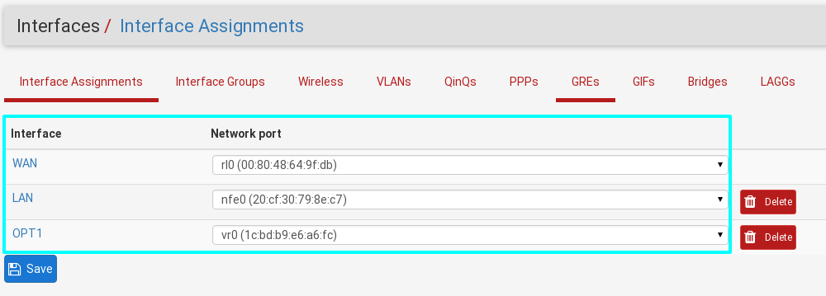
Step :2 Configure pfsense LAN interface

Opon the lan interfce using pfsense web page http://192.168.2.1. set the lan for below picture

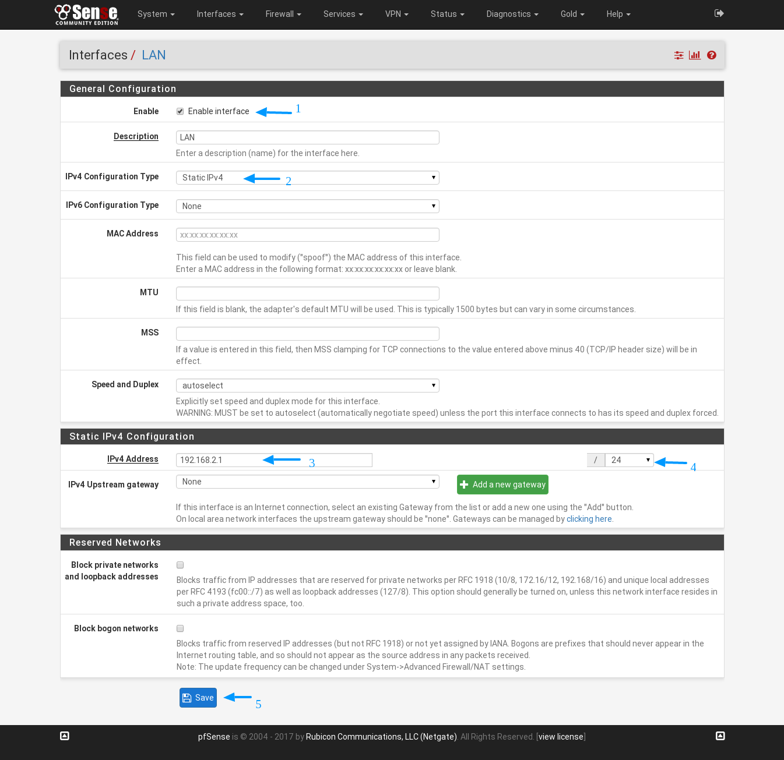
Finally save & apply the changes.

Step :3 Configure pfsense WAN interface

Open the lan interfce using pfsense web page http://192.168.2.1. set the WAN-1 for below picture

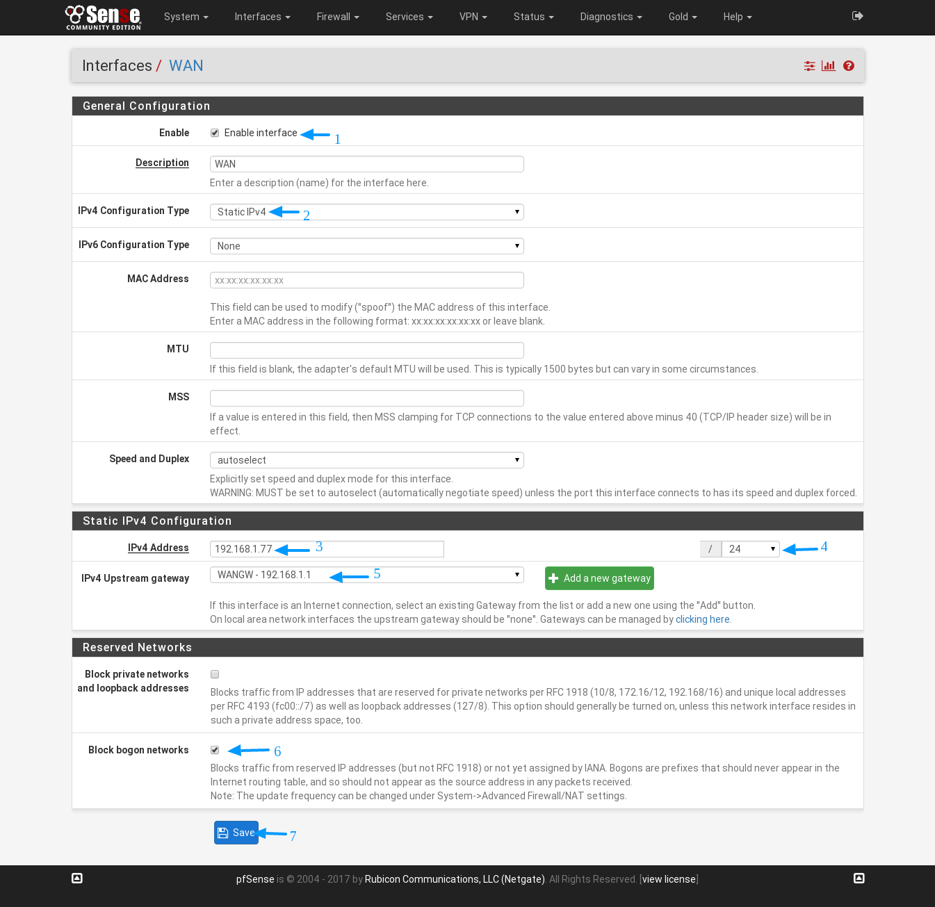
Save & apply the changes. Finally pfsense single LAN & single WAN configured ping with each other.

